EXPERIMENT 5
PRACTICE SQL COMMANDS FOR DML
AIM
Practice SQL COMMANDS FOR DML (insertion, updating, altering, deletion of data, and viewing/querying records based on condition in databases).
PROCEDURE
1.Create a database and relations according to the following schema.
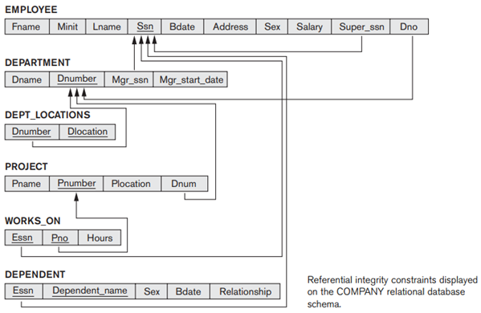
CREATE DATABASE FIRST;
USE FIRST;
CREATE TABLE EMPLOYEE(Fname VARCHAR(20),
Minit CHAR(3),
Lname VARCHAR(20),
Ssn INT NOT NULL,
Bdate DATE,
Address VARCHAR(50),
Sex CHAR(3),
Salary DECIMAL(7,2),
Super_ssn INT,
Dno INT,
PRIMARY KEY(Ssn),
CONSTRAINT fk1 FOREIGN KEY(Super_ssn) REFERENCES EMPLOYEE(Ssn));

SET FOREIGN_KEY_CHECKS=0;

INSERT INTO EMPLOYEE VALUE('John','B','Smith',123456789,'1965-01-09','731 Fondren,Houston,TX','M',30000,333445555,5);
INSERT INTO EMPLOYEE VALUE('Franklin','T','Wong',333445555,'1955-12-08','638 Voss,Houston,TX','M',40000,888665555,5);
INSERT INTO EMPLOYEE VALUE('Alicia','J','Zelaya',999887777,'1968-01-19','3321 Castle,Spring,TX','F',25000,987654321,4);
INSERT INTO EMPLOYEE VALUE('Jennifer','S','Wallace',987654321,'1941-08-20','291 Berry,Bellaire,TX','F',43000,888665555,4);
INSERT INTO EMPLOYEE VALUE('Ramesh','K','Narayan',666884444,'1962-09-15','975 Fire Oak,Humble,TX','M',38000,333445555,5);
INSERT INTO EMPLOYEE VALUE('Joyce','A','English',453453453,'1972-07-31','5631 Rice,Houston,TX','F',25000,333445555,5);
INSERT INTO EMPLOYEE VALUE('Ahmad','V','Jabbar',987987987,'1969-03-29','980 Dallas,Houston,TX','M',25000,987654321,4);
INSERT INTO EMPLOYEE VALUE('James','E','Borg',888665555,'1937-11-10','450 Stone.Houston,TX','M',55000,NULL,1);
SELECT * FROM EMPLOYEE;
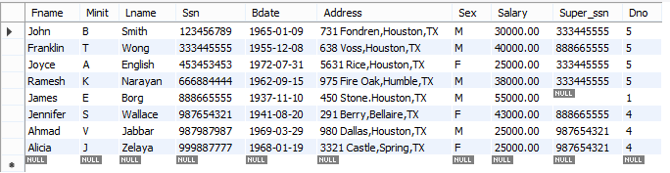
CREATE TABLE DEPARTMENT(Dname VARCHAR(30),
Dnumber INT NOT NULL,
Mgr_ssn INTEGER,
Mgr_start_date DATE,
PRIMARY KEY(Dnumber));
INSERT INTO DEPARTMENT VALUE('Research',5,333445555,'1988-05-22');
INSERT INTO DEPARTMENT VALUE('Administration',4,987654321,'1995-01-01');
INSERT INTO DEPARTMENT VALUE('Headquarters',1,888665555,'1981-06-19');
SELECT * FROM DEPARTMENT;
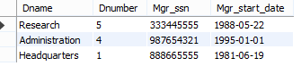

CREATE TABLE DEPT_LOCATIONS(Dnumber INT NOT NULL,
Dlocation CHAR(20) NOT NULL,
PRIMARY KEY(Dnumber,Dlocation),
CONSTRAINT dept_loc_fk1 FOREIGN KEY(Dnumber) REFERENCES DEPARTMENT(Dnumber));
INSERT INTO DEPT_LOCATIONS VALUE(1,'Houston');
INSERT INTO DEPT_LOCATIONS VALUE(4,'Stafford');
INSERT INTO DEPT_LOCATIONS VALUE(5,'Bellaire');
INSERT INTO DEPT_LOCATIONS VALUE(5,'Sugarland');
INSERT INTO DEPT_LOCATIONS VALUE(5,'Houston');
SELECT * FROM DEPT_LOCATIONS;
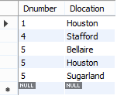
CREATE TABLE PROJECT(Pname VARCHAR(20),
Pnumber INT NOT NULL,
Plocation CHAR(20),
Dnum INT,
PRIMARY KEY(Pnumber),
CONSTRAINT project_fk1 FOREIGN KEY(Dnum) REFERENCES DEPARTMENT(Dnumber));
INSERT INTO PROJECT VALUE('ProductX',1,'Bellaire',5);
INSERT INTO PROJECT VALUE('ProductY',2,'Sugarland',5);
INSERT INTO PROJECT VALUE('ProductZ',3,'Houston',5);
INSERT INTO PROJECT VALUE('Computerization',10,'Stafford',4);
INSERT INTO PROJECT VALUE('Reorganization',20,'Houston',1);
INSERT INTO PROJECT VALUE('Newbenefits',30,'Stafford',4);
SELECT * FROM PROJECT;
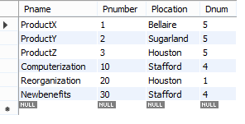
CREATE TABLE WORKS_ON(Essn INT NOT NULL,
Pno INT NOT NULL,
Hours TIME,
PRIMARY KEY(Essn,Pno),
CONSTRAINT works_onfk1 FOREIGN KEY(Essn) REFERENCES EMPLOYEE(Ssn),CONSTRAINT works_onfk2 FOREIGN KEY(Pno) REFERENCES PROJECT(Pnumber));
INSERT INTO WORKS_ON VALUE(123456789,1,'32:05:00'),
(123456789,2,'07:05:00'),
(666884444,3,'40:00:00'),
(453453453,1,'20:00:00'),
(453453453,2,'20:00:00'),
(333445555,2,'10:00:00'),
(333445555,3,'10:00:00'),
(333445555,10,'10:00:00'),
(333445555,20,'10:00:00'),
(999887777,30,'30:00:00'),
(999887777,10,'10:00:00'),
(987987987,10,'35:00:00'),
(987987987,30,'05:00:00'),
(987654321,30,'20:00:00'),
(987654321,20,'15:00:00'),
(888665555,20,NULL);

SELECT * FROM WORKS_ON;
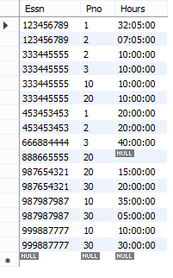
CREATE TABLE DEPENDENT(Essn INT NOT NULL,
Dependent_name VARCHAR(20),
Sex VARCHAR(1),
Bdate DATE,
Relationship VARCHAR(10),
PRIMARY KEY(Essn,Dependent_name),
CONSTRAINT dependentfk1 FOREIGN KEY(Essn) REFERENCES EMPLOYEE(Ssn));
INSERT INTO DEPENDENT VALUE
(333445555,'Alice','F','1986-04-05','Daughter'),
(333445555,'Theodore','M','1983-10-25','Son'),
(333445555,'Joy','F','1958-05-03','Spouse'),
(987654321,'Abner','M','1942-02-28','Spouce'),
(123456789,'Michael','M','1988-01-04','Son'),
(123456789,'Alice','F','1988-12-30','Daughter'),
(123456789,'Elizabeth','F','1967-05-05','Spouse');
SELECT * FROM DEPENDENT;

